SOP of Backing up the PecStar iEMS V3.5 Database

Use Database Manager to back up the PecStar V3.5 Database
The backup action can create an entire backup for the PECSTAR_CONFIG and PecStar_DATA databases. Here are the steps:

- Confirm the connection information of the database that you want to backup. Make sure the information is correct. Please refer to Specify a Database Connection in DatabaseConfig.

- Start the DatabaseManager.exe program in the D:\CET\Common path.

- Click Backup on the left list. It will bring you the following interface:
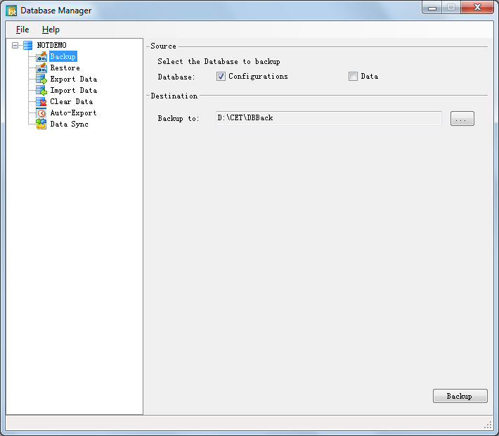

Source: select the database that you want to backup. You can back up either the Configuration database or the Data database or both of them. If you choose Configuration, the configuration and data structure will be backed up.
Destination: click the browse button to specify a location to save the backup.
- Then click the Backup button . Only users with the Backup Historical Data authority can back up the database. Input the user name and password.
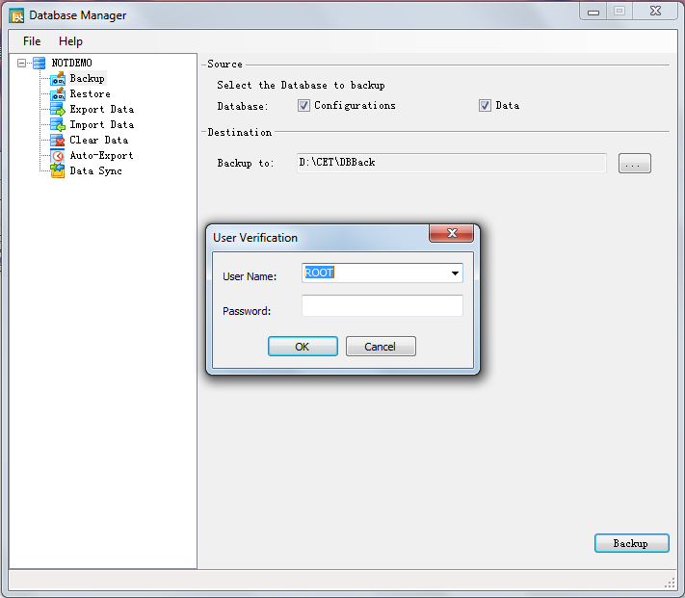
- Click OK to begin the backup process.
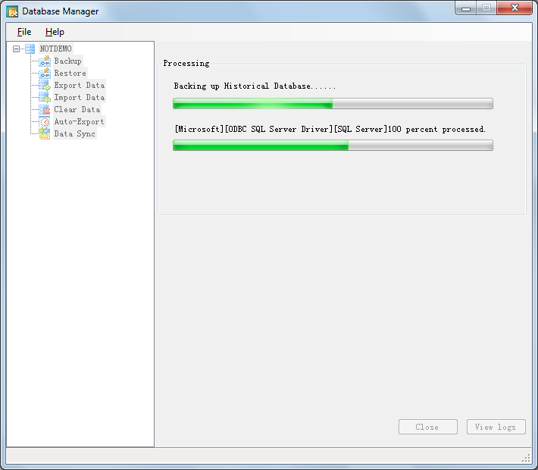
- Click Close when completed or click View logs to see details.
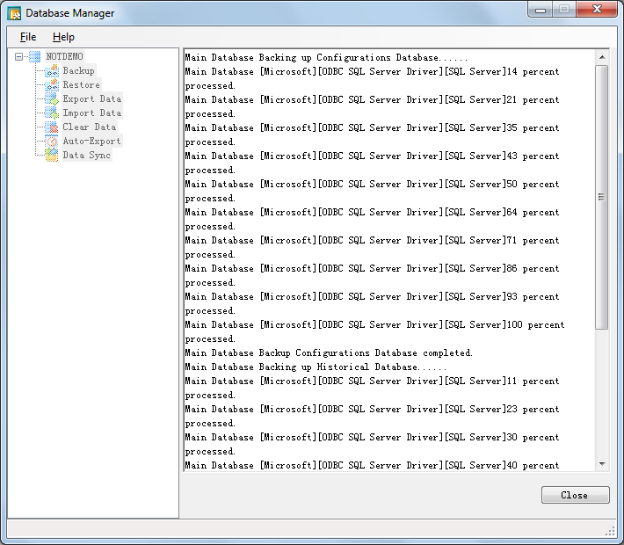
If you choose to backup both the Configuration and the Data database, then two files will be generated:
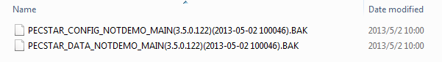
For backing up only the Configuration database, three files will be generated:
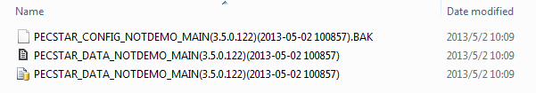
For backing up only the Data database, one file will be generated:
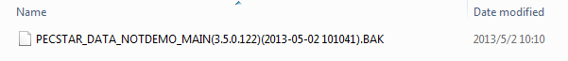

Specify a Database Connection in DatabaseConfig
The DatabaseConfig program is used to specify the PecStar iEMS database connection. It helps you to modify and defined the main and standby database server connections of PecStar iEMS.
Double-click the DatabaseConfig.exe program in the in the D:\CET\Common path of the PecStar iEMS install path. Then it will bring you the PecStar Database Connection interface. Check all the information and see if they are correct.
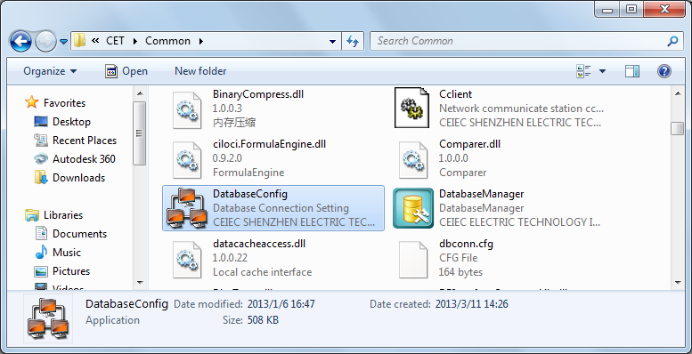
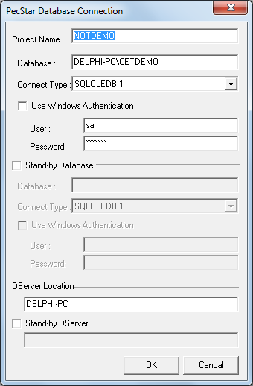
Project Name: the name of the database for iEMS.
Database: the connected database instance of PecStar iEMS.
Connect Type: If the database server is SQL Server edition, please select SQLOLEDB.1.
Use Windows Authentication: select this if the SQL Server Login required the Windows authentication. Generally, the PecStar iEMS database uses the SQL Server authentication that requires a user name and password.
Stand-by Database: select this if a standby database server is connected. And then input the database instance and user account information in the following boxes.
Dserver Location: input the computer name or IP address where the main Dserver module is located.
Stand-by Dserver: input the computer name of IP address where the standby Dserver module is located.
Click OK, the program will save the information you input.

